Different ways of upgrading the voice commands to the speech recognition chip：
Currently, we have two methods to upgrade the voice commands, and upgrading through VCP is the simplest one.

- Upgrade via USB to TTL small board, please refer to：HellRadioSky Voice Assistant Upgrade.pdf
- Upgrading through the VCP of the radio is relatively simple. Please refer to the following steps for the operation process。
- The radio software must be upgraded to 0919... or higher versions.
- Copy the Speech tools folder from SD card of the radio to your computer
- Install the VCP_V1.3.1_Setup virtual serial port driver on your computer. Please note that your computer requires Win7 or higher version. If you have already successfully installed it, please skip this step.
- Turn on the radio, and connect the USB data interface with the computer. Select USB Serial Port (VCP) on the radio.
- In the device manager of your computer, you should be able to see a serial port device STM as shown in the figure below, indicating that your driver installation is successful. Otherwise, you may need to check if the driver installation or USB connection is good. Repeat steps 5-7 until you successfully see the following port
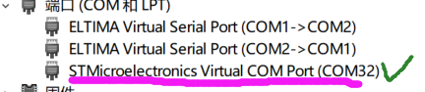
- Start the upgrade tool on the computer and follow the process shown in the figure below. The upgrade is expected to be completed in about 3 minutes
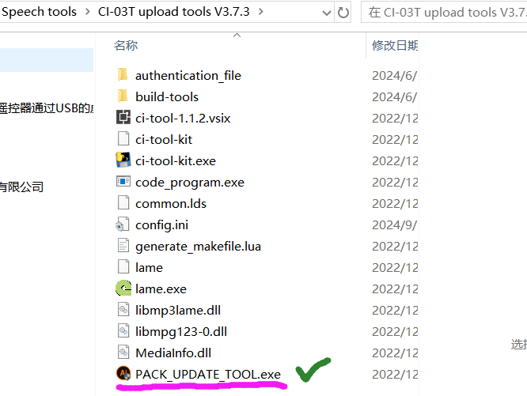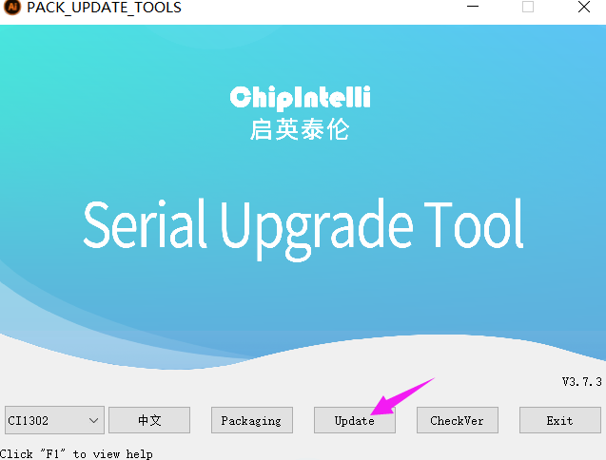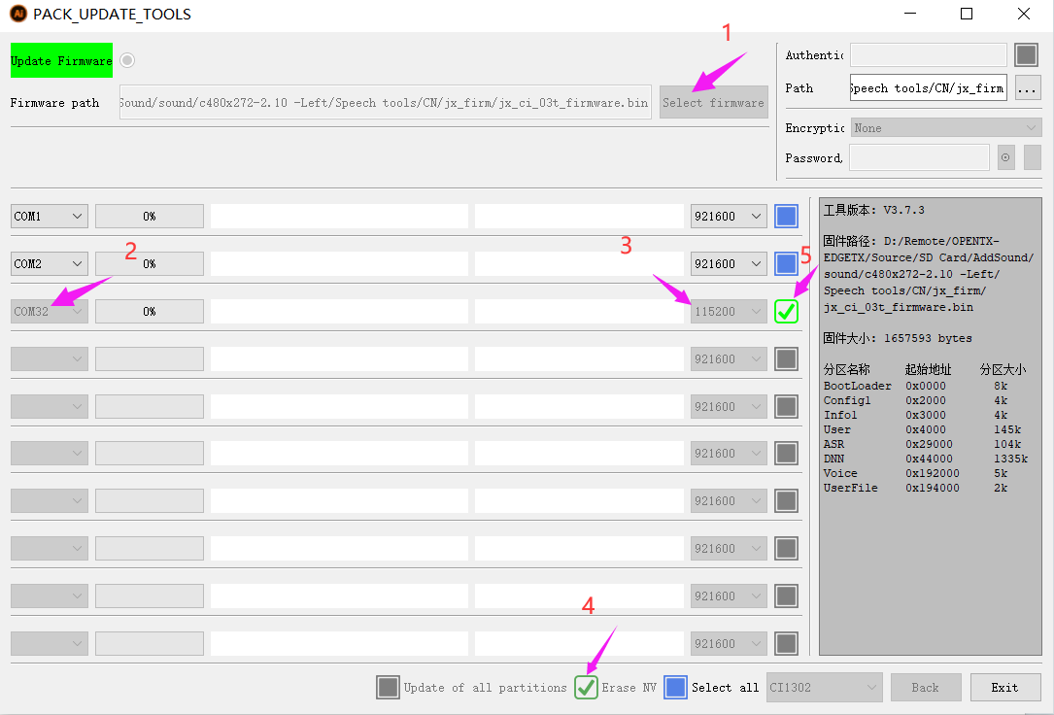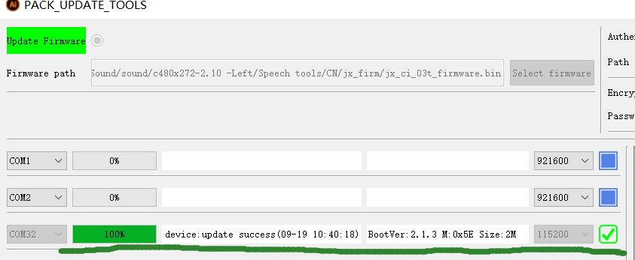
- When the 100% mark appears, you need to disconnect your USB connection or close the upgrade tool. By following the above steps, upgrading voice commands will become easier and more convenient. Have a great time.

HelloRadioSky QQ技术交流群：83162463
https://www.helloradiosky.com

